**EXPERIMENT 1**

1. **whoami**

To get the username

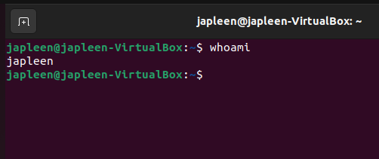

1. **hostname**

To get the hostname

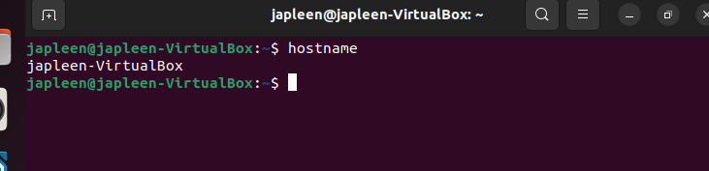

1. **pwd**

print working directory

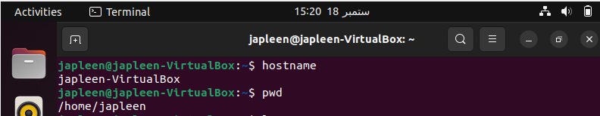

1. **cd<directory name>**

To enter the directory

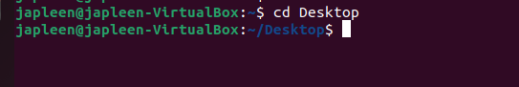

1. **cd..**

To get to the previous directory/ change directory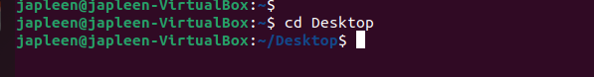

1. **ls**

to list the information of files

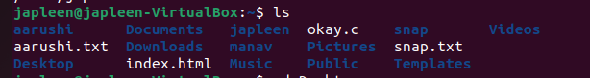

1. **ls -l**

List the directories including hidden and with other details

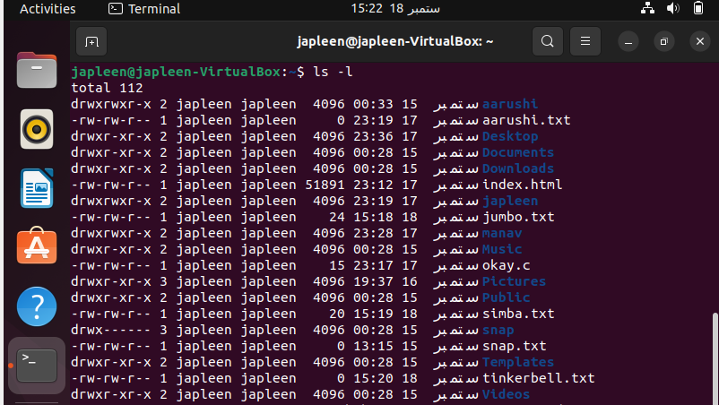

1. **touch<filename>**

To go to a home directory

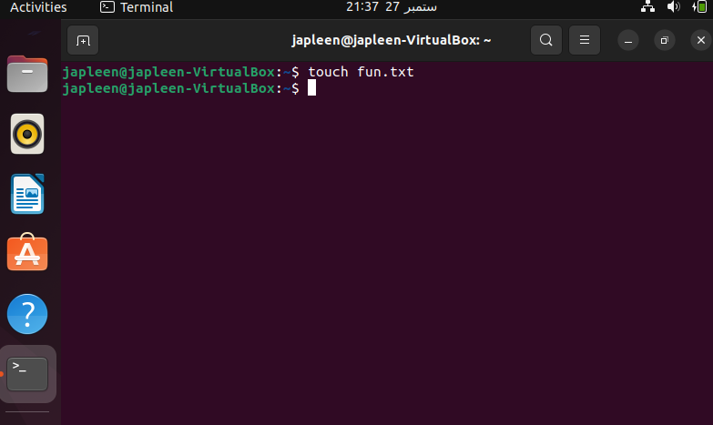

1. **touch<filename> {from..to}**

To create multiple files ending with from to to

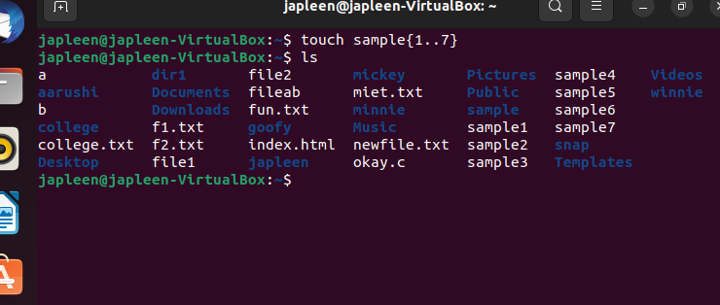

1. **vi/nano**

Open the writing mode

**Vi**

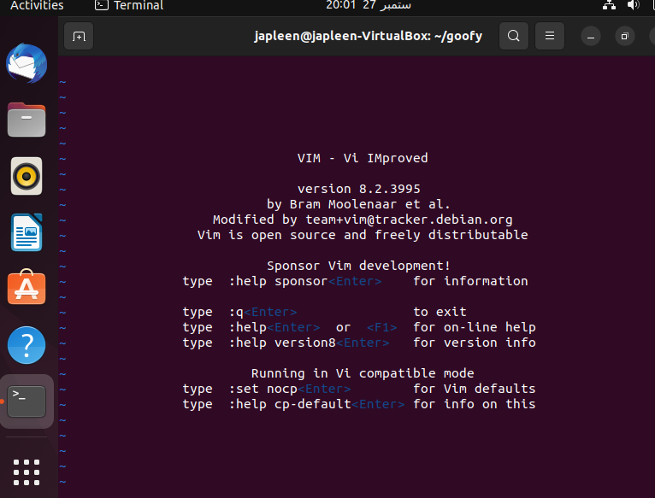

**Nano**

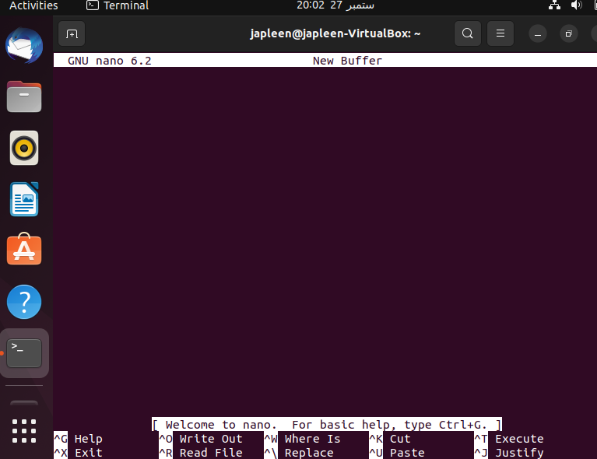

1. **vi/nano<filename>**

create a file and open in writing mode

**vi**

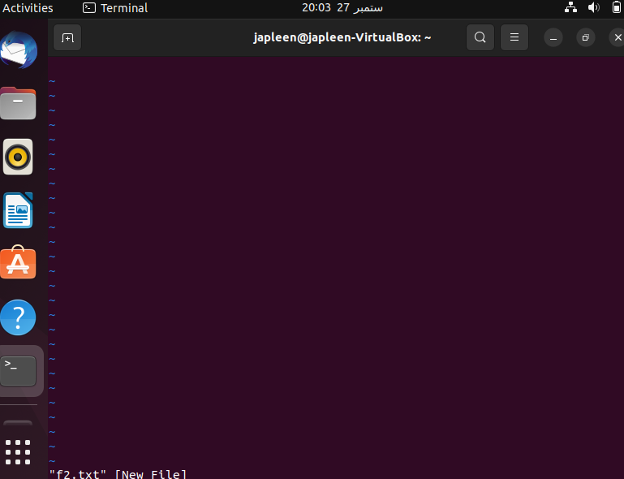

**nano**

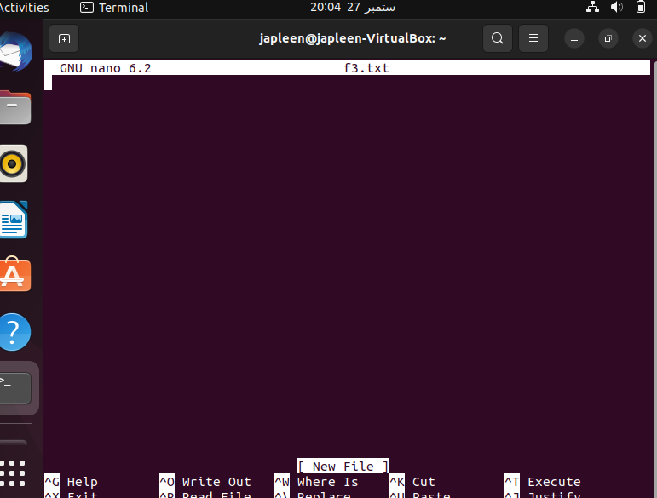

1. **mkdir<directory name>**

Creates a directory

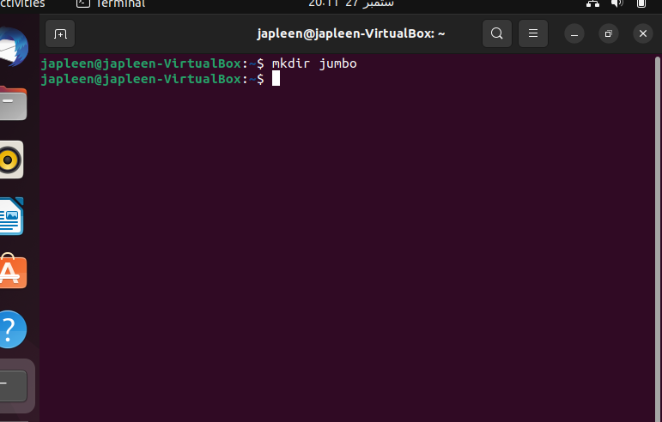

1. **mkdir -p dir1/dir2/dir3**

Used to create directory within a directory

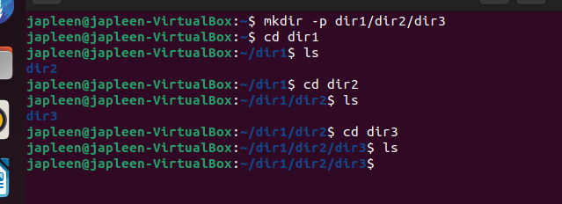

1. **mkdir -v <directory name>**

creates a directory and gives output status

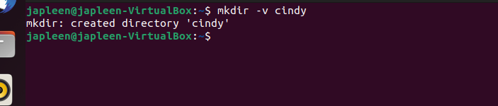

1. **rm<filename>**

To delete a file

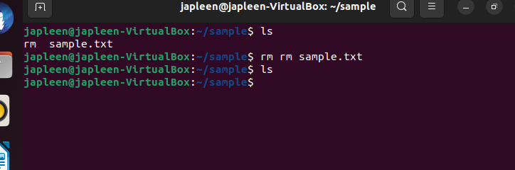

1. **rmdir<directory name>**

To delete an empty directory

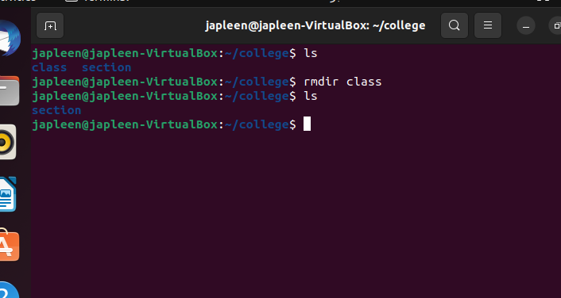

1. **rm -r<directory name>**

To remove directory

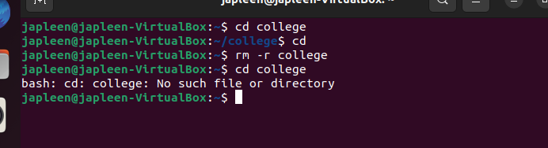

1. **unlink<filename>**

To remove single file

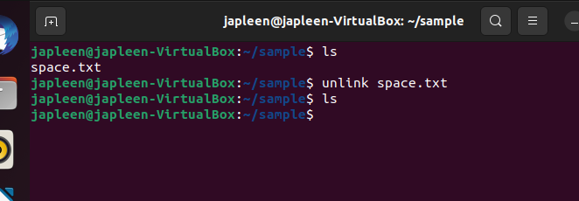

1. **rm *.pdf or rm *.txt**

to remove multiple files

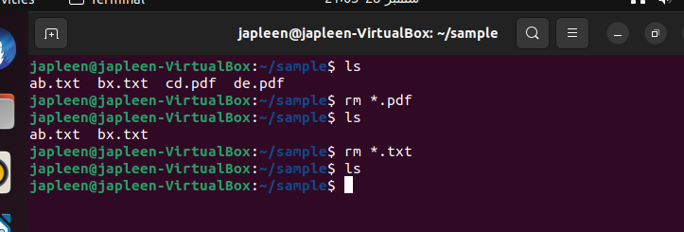

1. **rm -i *.pdf or rm -I *.txt**

Requires permission for deleting files within a directory

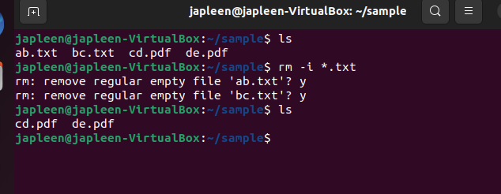

1. **mv<old filename><new filename>**

To renaming a file

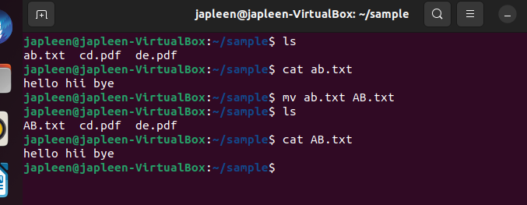

1. **mv<file name><path where to move>**

To move a file

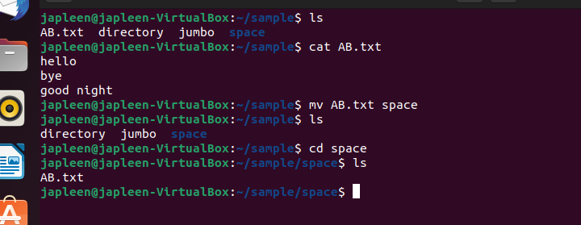

1. **mv -i <file name><path where to move>**

To move a file and take permission to overwrite if file exits

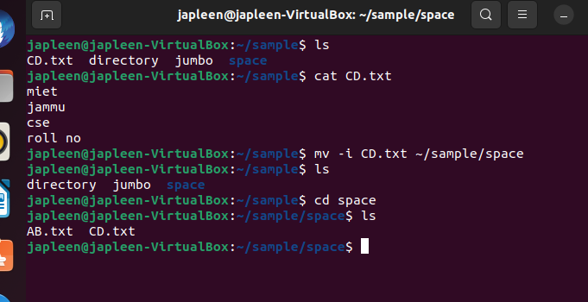

1. **mv -n<filename><path where to move >**

To move a file but reject for overwriting if file already exists

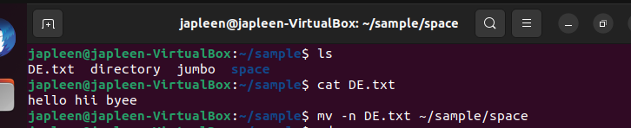

1. **cp<old filename><new filename>**

to copy a file

